Week 1 Module 1.3 Assignment
XAMPP and Test

Juan Macias Vasquez
Bellevue University
CSD440-H323 Server-Side Scripting (2265-DD)
Jack Lusby
March 27th, 2026

Week 1 Module 1.3 Assignment
XAMPP and Test
GitHub Repository
https://github.com/Juan551School/csd-440
Code used
JuanMaciasFirstProgram.php
// Module 1_3 Assignment
// Juan Macias Vasquez
// Bellevue University
// CSD440-H323 Server-Side Scripting (2265-DD)
// Jack Lusby
// March 27th, 2026

<!DOCTYPE html>
<html>
<head>
<title>First PHP Program</title>
</head>
<body>

<h1>Welcome to My First PHP Program</h1>

<?php
// This is the first PHP code snippet
// It shows a simple message with my name
echo "<p>Hello, my name is Juan Carlos Macias Vasquez</p>";
?>

<?php
// This is the second PHP code snippet
// It displays the current date and time
date_default_timezone_set("America/Denver");
echo "<p>Today's date is: " . date("Y-m-d") . "</p>";
echo "<p>The Current time is: " . date("h:i:s A") . "</p>";
?>

</body>
</html>

test.php
<?php
phpinfo();
?>

Pictures of XAMPP working correctly
XAMPP Control Pannel
With Apache and MySQL Running and Webpage working in browser
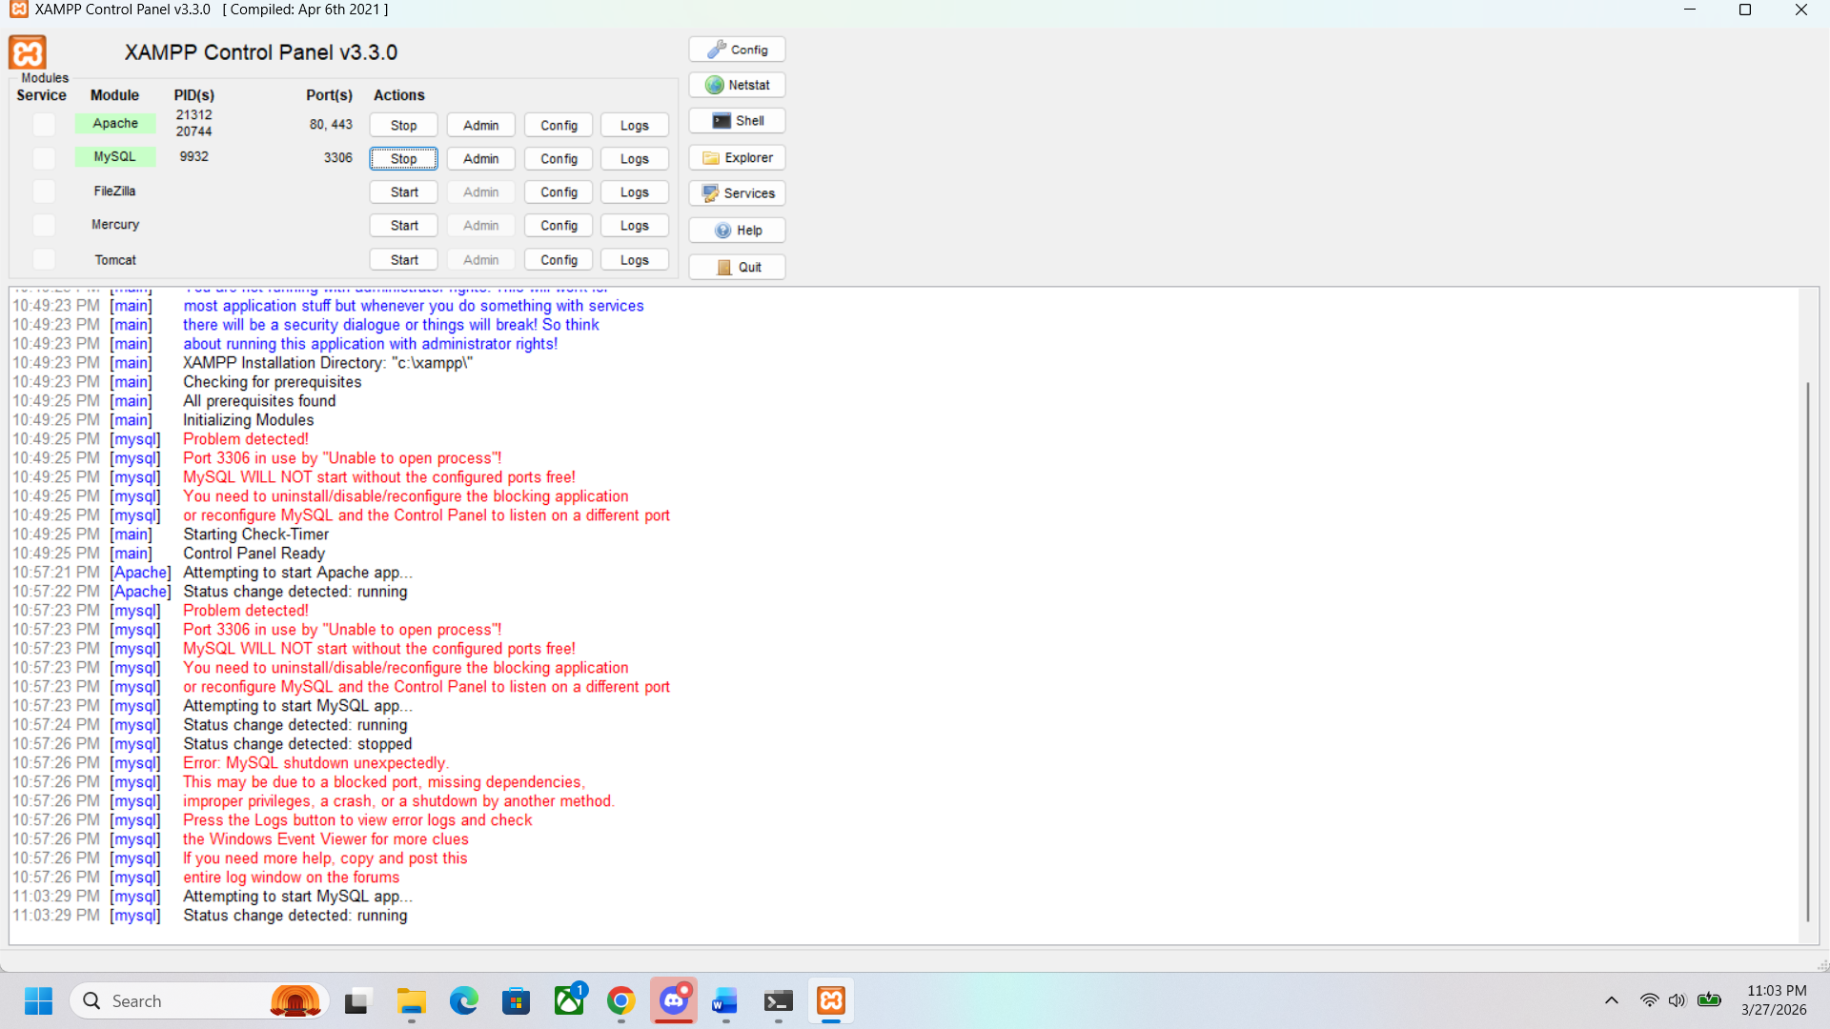
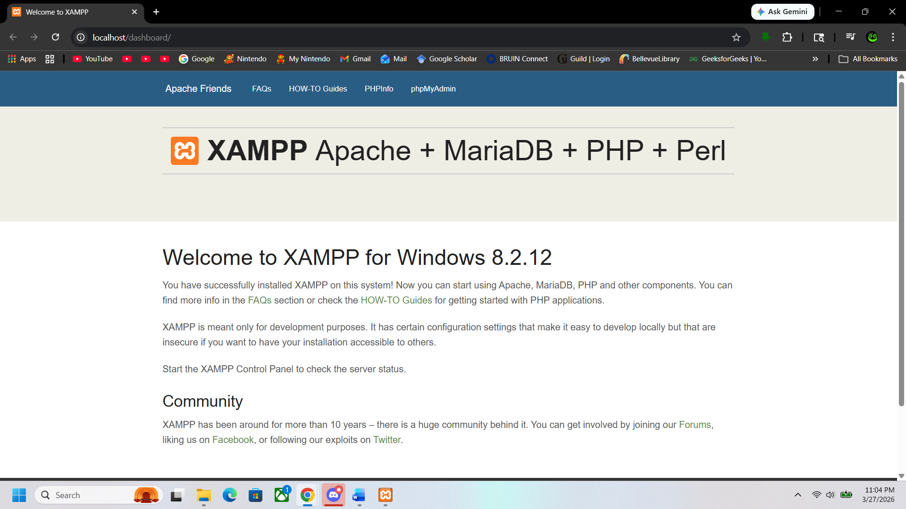
Local host webpage working correctly
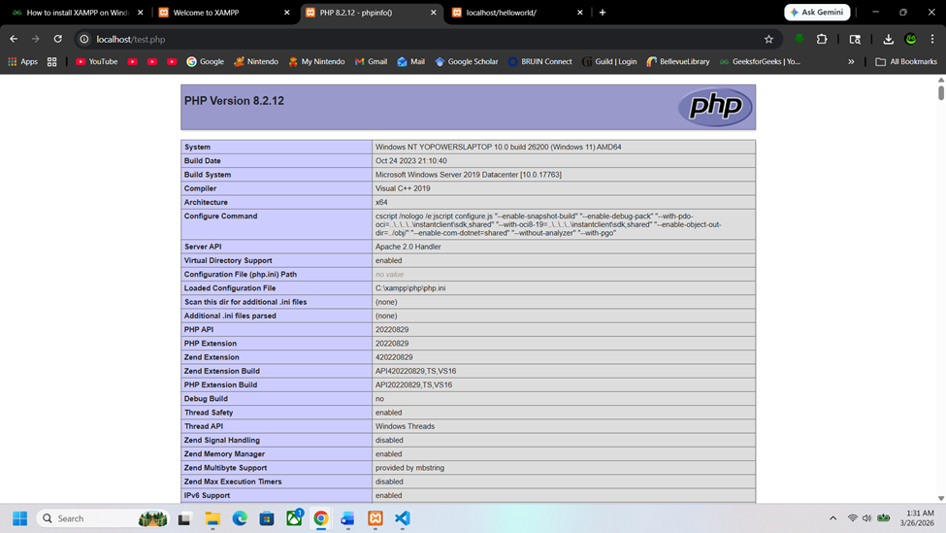
JuanMaciasFirstProgram.php
http://localhost/JuanMaciasFirstProgram.php
